09 December 2013

Telerik Academy Spring 2013 OOP Team Project

Garage management system

team hematite

# Team Information

## Team “Hematite” is:

* Николай Радков, a.k.a Nikolay_Radkov
* Димитър Михов, a.k.a mitko_mihov
* Ива Дончева, a.k.a IvaDoncheva
* Илиян Йорданов, a.k.a iliandj
* Любен Хранов, a.k.a lhranov

# Project details

Name. The name of the team project is Garage Management System – a simple and intuitive system for managing an auto repair shop

Purpose. The main goal of the project is to provide an adequate software for running an auto repair shop, by providing functionality supporting the day-to-day operations of such establishments, such as (but not limited to) keeping a registry of serviced cars, distributors, employees, supporting the process of a repair (parts, time frame, markup), communication with related parties, tasks lists and many others.

# Class diagram

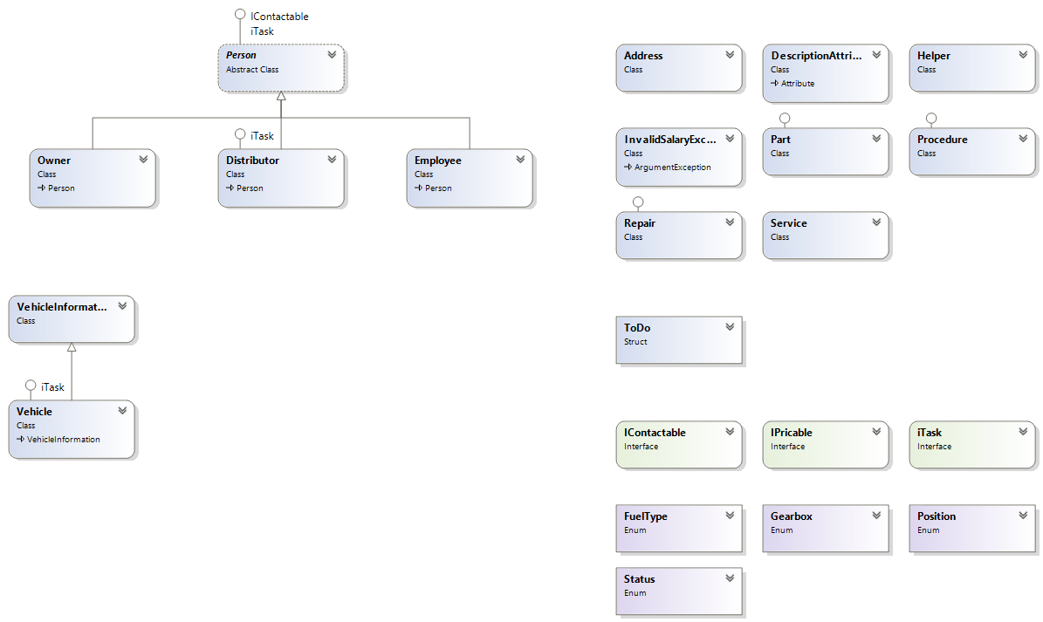

# SVN repository

General Information. For this project we have used Google’s Code SVN hosting service. All of the team members, who wanted to contribute to the project with adding to the code were added as owners of the project.

URL. <https://code.google.com/p/hematite-team/>

# Additional information

Due to the complexity of the project, it is not fully finished. The main classes and interface are there, as well as the core UI, but the following list is the main features that still need to be implemented:

* Implement contacting (sending SMS or email) related parties (i.e. distributors or car owners) directly from the system
* Creating a catalogue of parts, that are related to specific vehicles (Manufacturer/Model/Year) and being able to send requests for purchase/delivery to the distributors that have that part from the system
* Adding different settings options to the UI – i.e. metrics, language, default reminder time, time zone etc.
* Implementing the task creation, maintenance and reminding into the UI

We would like to thank everyone, who got involved in the project and the Telerik Academy for providing the opportunity to be a part of such an undertaking.